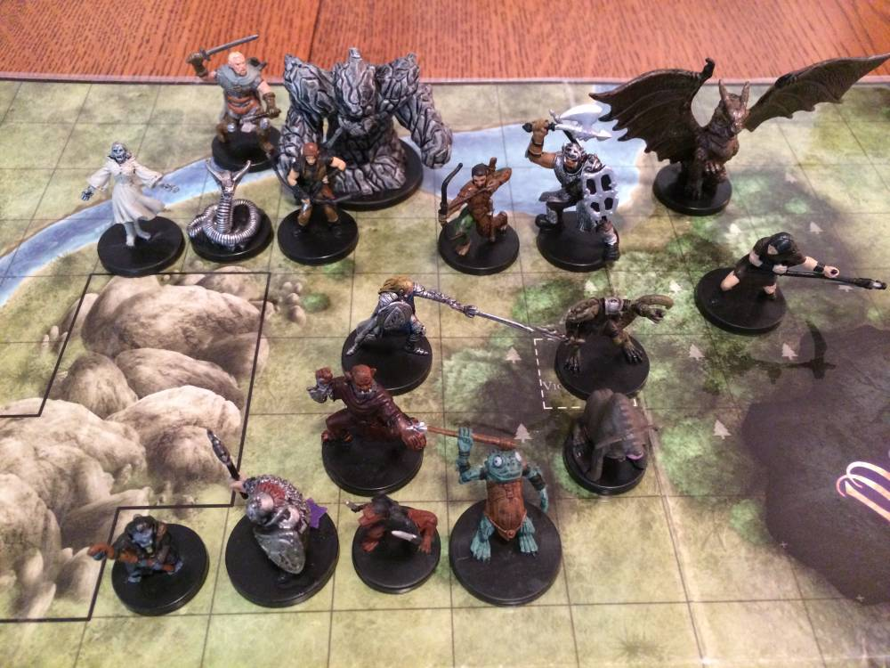
D&D Minis (DDM)

Photo Credit: Ira Fay

Part 1 Due before class on 2/5
Part 2 Due before class on 2/17
Part 3 Due before class on 3/3
Part 4 Due in class on 3/10
Part 5 and Beyond TBD

For this project, you will learn, play, analyze, and design the D&D Miniatures (DDM) skirmish game. This assignment is intended to be fun, and to help you increase your skills in the following areas:

- Reading, learning, and retaining complex game rules
- Understanding an existing game that has significant history
- Interacting with an active player community
- Analyzing a complex game for game balance and other issues
- Debugging an existing game
- Improving an existing game
- Writing game rules
- Networking with peers

Part 1
By the deadline, complete the following tasks:
- Pay the $40 materials fee to Ira and collect your minis + map from Ira
- Print out the cards for each of your minis here: http://irafay.com/DDM
- Learn the rules of DDM
- Create a 50 or 100 point warband for the Arena format
- Play a sample game with your partner

Teams
You may name your team as you see fit. For now, I’ll simply use numbers:

1: Ethan Ferris, Bryan Prieto
2: Kahari Mickens, Konstantin Kahl
3: Quinlan Schultz, Martha Hollister
4: Quinn Roberts, May Gaudet
5: Amara Taylor, Meghan Straus
6: Jonathan Kittell-Queller, Noah Marcus
7: Freya Crowe, Aidan Alice West
8: Will Dorrell, Jesse Carreno
9: Caleb Finkelstein, Sean Billson
10: Dan Homer, Kwame Allen-Roberts
11: Amory Wright, Joe Bir
12: Jessica Goldsmith, Ethan Cyr
13: Alex Durkee, Alexander Hellmann, John Sander

Part 2
So far, we have focused on 100-point Arena (5 minis max) games, using only the minis that you have on hand. Let’s expand! Let’s increase to 200-point warbands, and imagine you had access to all the DDM creatures that have ever been made. Consider two formats: Arena (5 minis, small size map) and Gladiator (2 minis hard limit, small size map).

By the deadline, research and create the most powerful 200-point Arena warband and 200 point Gladiator warband and submit them here:
https://docs.google.com/forms/d/1FRS0DVmckb5NezqB-oA2Mq9ue-qaQldwZn46-zpgwNs

You may complete the form repeatedly if you want to submit multiple different warbands for each format, but only one entry is required.

Please bring to class one printed page of your Arena warband and another for your Gladiator warband. You don’t need to cut out the cards. You can easily get a printable page here: http://irafay.com/DDM

Part 3
To start the transition from DDM player to DDM designer, please carefully read all the Collected Rulings. They are available here:
http://irafay.com/DDM, and then click on Collected Rulings in the nav bar

Make notes as you read for any ruling that seems incorrect or confusing.

Once you’ve read all the Rulings, then look at the bottom of that spreadsheet and click on the “Rulings Under Discussion” tab. Read all of those too, making notes as you go.

Once you’ve read both the Rulings and Rulings Under Discussion, complete the survey below:
https://docs.google.com/forms/d/1Ywxj_5yX9s3DP_yWWNl3CazfT2TScpN220QWjsdzPu8

The survey asks you to:
A) Identify at least three rules questions/ambiguities that aren’t already covered in the existing Collected Rulings.

B) Propose a final ruling for three of the Rulings Under Discussion, using your own judgment as if you were the lead designer of DDM.

Part 4
We will play an in-class tournament on this day. Bring a 200-point Arena warband, printed out cards, a d20, and a map. Unlike a normal tournament, we will be awarding points for various things beyond just gameplay. Specifically:

- Asking a rules question (based on your current game) that isn't answered by the rulebook or the Collected Rulings
  - 0 – 100 points to both players, based on quality of question

- Asking a rules question that you could have answered yourself by reading the rules or Collected Rulings
  - Negative 0 – 10 points to both players, depending on the question

- Arriving at class prepared to play (d20, printed warband, map, minis)
  - 20 points

- Winning your game
  - 20 points

- Losing your game
  - 15 points

- Other things at Ira’s discretion

Also, prior to the tournament, you may ask to borrow minis from Ira’s personal collection and/or proxy minis. The more notice you give me, the more likely it is I’ll be able to bring them for you (assuming I own it). Obviously the resourceful tournament player will research complex rules scenarios to maximize points.

Oh, and you’ll be playing your partner, so feel free to coordinate warbands for maximum rules complexity. For the three person group, I’ll bring a warband myself, and if we have an odd number of people in class that day, I’ll play. Feel free to email me to suggest a specific warband.

Part 5 and Beyond
TBD

Original assignment designed by Professor Ira Fay.

